Name

Mathematics Stage 5 Paths
Similar Areas
and Volumes

Book 1 |  | Version: 261007  Feedback:  https://MrDingMaths.com
Contents
Syllabus Content 2
Learning Intention 3

Syllabus Content
MA5-GEO-P-01 establishes conditions for congruent triangles and similar triangles and solves problems relating to properties of similar figures and plane shapes
Establish and apply properties of similar shapes and solids
- Establish for 2 similar figures with similarity ratio $a:b$ that their areas are in the ratio $a^{2}:b^{2}$ and their volumes are in the ratio $a^{3}:b^{3}$
- Solve problems involving areas and volumes of similar shapes and solids

Areas of Similar Figures

- Area of similar figures
The diagrams below show two similar rectangles, with the second being an enlargement.
Original  2 cm  1 cm  $A_{1}=$ ……………… | Image  4 cm  2 cm  $A_{2}=$ ………………
The length ratio of original : image is: …………………
The area ratio of original : image is: …………………
Original  2 cm  1 cm  $A_{1}=$ ……………… | Image  6 cm  3 cm  $A_{3}=$ ………………
The length ratio of original : image is: …………………
The area ratio of original : image is: …………………

- Areas of Similar Shapes
If two figures are in the ratio $a:b$
their areas are in the ratio $a^{2}:b^{2}$

- Determine ratio of lengths.
- Determine ratio of areas.
- Use a ratio table to find area of unknown.

- Example Calculate area of similar figures
A triangle has been enlarged with scale factor of $k=3$. The original area is 10 cm^{2.}
Calculate the area of the enlarged triangle.
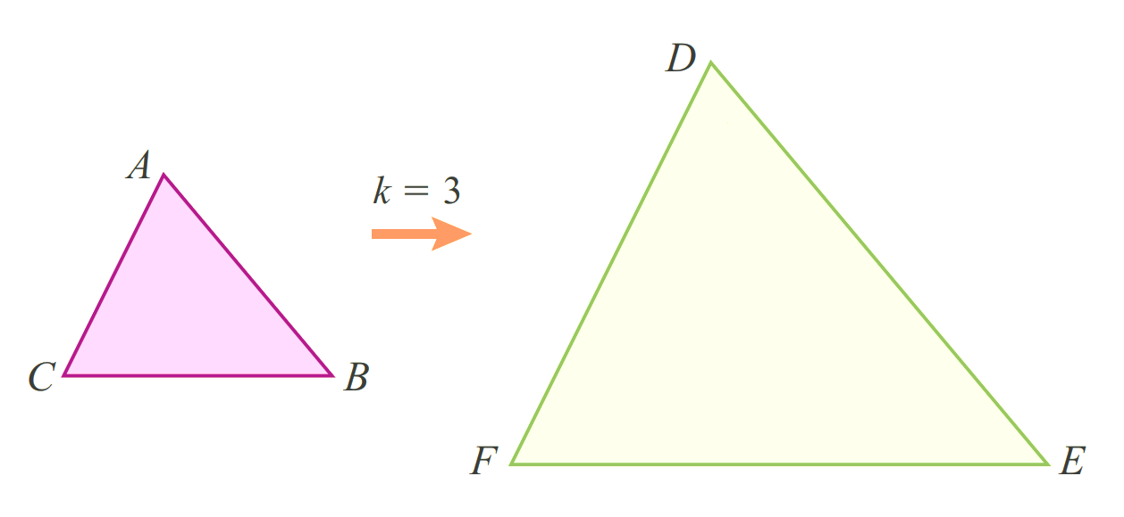
10 cm²

1. Length ratio: $1 :3$
2. Areas in ratio: $1^{2} :3^{2}$
$=1 :9$
3. Ratio table:
Original | $$:$$ | Image
1 | $$:$$ | 9
10 | $$:$$ | 90

The area of the enlarged figure is 90 cm².

- Guided Practice
Calculate the areas of these similar figures.
1. Length ratio:  2. Areas in ratio:  3. Ratio table:  117 cm² | 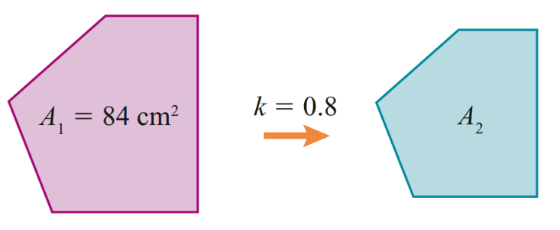  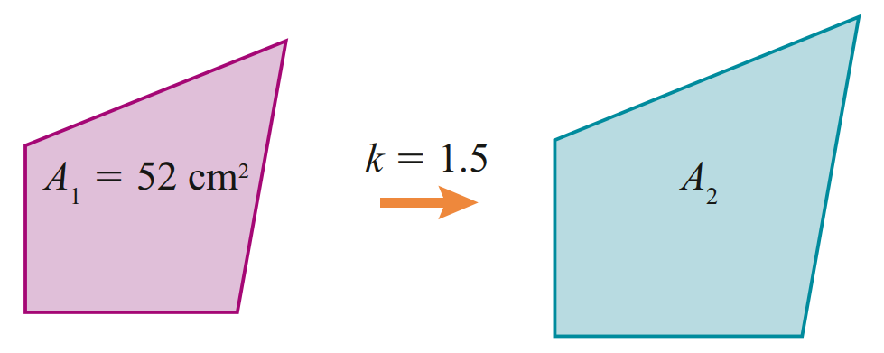  53.76 cm²
  Original | $$:$$ | Image
   | $$:$$
   | $$:$$
  Original | $$:$$ | Image
   | $$:$$
   | $$:$$

Foundation
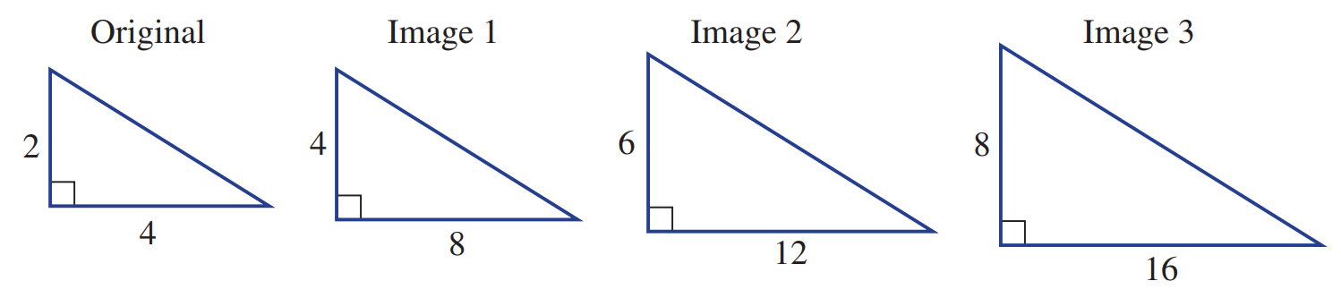
- Consider these three similar triangles (not drawn to scale). All units are in cm.

  - Complete this table, comparing each image to the original.
Triangle | Original | Image 1 | Image 2 | Image 3
Length ratio | 1 | 1:2 | 1:3 | 1:4
Area | 4 cm² | 16 | 36 | 64
Area ratio | 1 | 1: ……  4 | 1:9 | 1:16

  - What would be the area ratio if the length ratio is $1:n$?
$$1:n^{2}$$
  - What would be the area ratio if the length ratio is:
    - 1:10? ………… ii 1:20? ………… iii 1:100? …………
1:100 1:400 1:10 000
  - What would be the area ratio if the length ratio is $1:\frac{1}{2}$? ………………………
$$1:\frac{1}{4}$$
- Use the information given to find the unknown area for each pair of similar figures.
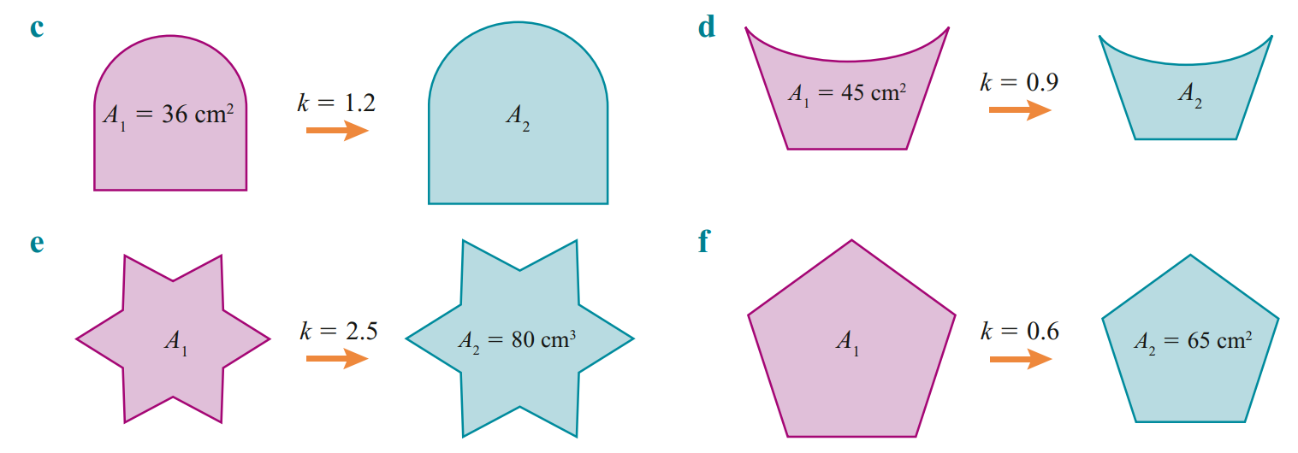  1. Length ratio:  2. Areas in ratio:  3. Ratio table:  51.84 cm² | 36.45 cm²
  Original | $$:$$ | Image
  1 | $$:$$ | $$1.2^{2}$$
  36 | $$:$$ | 51.84
12.8 cm² | 180.$\dot{5}$ cm²

Development
- These shapes are similar.
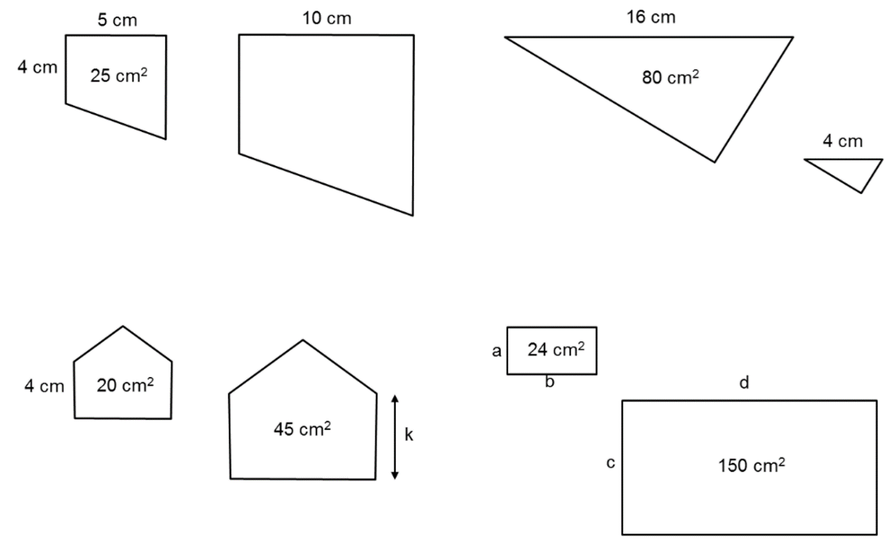  - What is the area of the larger shape?  $${\left(\frac{10}{5}\right)}^{2}=\frac{x}{25}$$  $x=100$ cm² | - What is the area of the smaller shape?  $$\frac{x}{80}={\left(\frac{4}{16}\right)}^{2}$$  $x=5$ cm²
- What is the length $k$?  $${\left(\frac{k}{4}\right)}^{2}=\frac{45}{20}$$  $k=6$ cm | - Find some values of $a$, $b$, $c$, $d$ if they are all integers.  $$k^{2}=\frac{150}{24}$$  $$k=2.5$$  $a,b$ are factor pairs of 24 and $c,d$must be factors pairs of 150:  Possible 4-pairs of $\left(a,b,c,d\right):$  $$\left(2, 12, 5, 18\right)$$  $$(4, 6, 10, 15)$$  $$\left(6, 4, 15, 10\right)$$  $$(12, 2, 18, 5)$$

- A scale diagram of a park uses a scale of 1 cm = 10 m.
  - Write this as a ratio; remember that ratios always have the same units for both quantities.

$$1:1000$$
  - A park is 15 cm across on the diagram. Work out the equivalent distance in real life in m.

$15 cm×1000=15000$cm = 150 m
  - A playground in the park as an area of 4.3 cm² on the diagram.
Work out the area the playground takes up in real life in m²
4.3 cm² $×{1000}^{2}$ = 4 300 000 cm² = 430 m²

- A map is drawn to a scale of 1:1000. That means the area is in the ratio 1:1000².
  - The area of a nature reserve is 3.6 ha (1 ha = 10 000 m²).
What will be its area on the map, in square metres?

$36 000 m^{2}÷{1000}^{2}=0.036$m²
  - What is this is square centimetres?
$0.036×{100}^{2}=360$ cm²
  - The area on the map of a school and its playgrounds is 96 cm².
What is its actual area in ha?

$96×{1000}^{2}=96 000 000$ cm² = 9600 m² = 0.96 ha
- The ratio of the area of a field on a scale drawing to its actual area is 1 : 2500.
What is the ratio of the dimensions of the field on the diagram to its actual dimensions?

$$1:\sqrt{2500}=1:50$$
- The matching sides of two similar figures are in the ratio 4 : 5.
  - Write the area ratio of the smaller to the larger prism.

$$16:25$$
  - If the area of the larger figure is 600 cm², what is the area of the smaller solid?

Areas in ratio 16 : 25
$$600×\frac{16}{25}=384 cm^{2}$$

Volumes of Similar Solids

- Volumes of similar figures
The diagrams below show two similar rectangles, with the second being an enlargement.
Original  2 cm  1 cm  $A_{1}=$ ……………… | Image  4 cm  2 cm  $A_{2}=$ ………………
The length ratio of original : image is: …………………
The area ratio of original : image is: …………………
Original  2 cm  1 cm  3 cm  $V_{1}=$ ……………… | Image  6 cm  3 cm  9 cm  $V_{2}=$ ………………
The length ratio of original : image is: …………………
The volume ratio of original : image is: …………………

- Similar Areas and Volumes
If two figures are in the ratio $a:b$
their areas are in the ratio $a^{2}:b^{2}$
their volumes are in the ratio $a^{3}:b^{3}$

- Determine ratio of lengths.
- Determine ratio of volumes.
- Use a ratio table to find area of unknown.

- Example Calculate volume of similar figures
A cylinder has been enlarged with scale factor of $k=4$. The original volume is 12 cm³, calculate the volume of the enlarged cylinder.
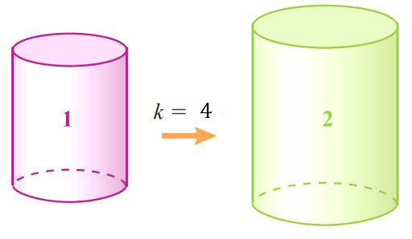
12 cm³

1. Length ratio: $1 :4$
2. Volumes in ratio: $1^{3} :4^{3}$
$=1 :64$
3. Ratio table:
Original | $$:$$ | Image
1 | $$:$$ | 64
12 | $$:$$ | 768

The volume of the enlarged figure is 768 cm³.

- Guided Practice
Calculate the volumes of these similar solids.
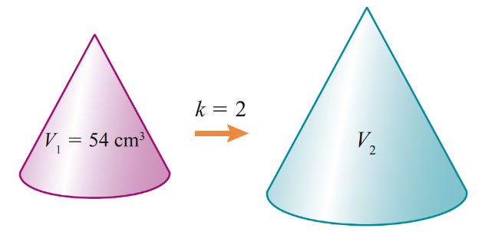  432 cm³ | 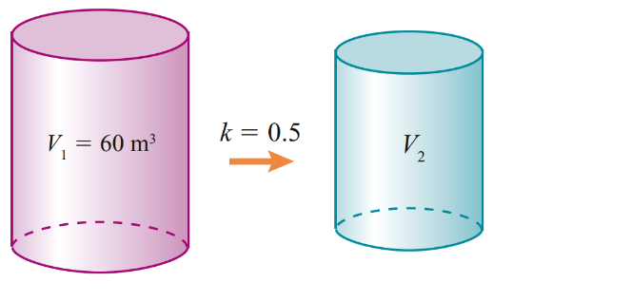  7.5 m³

Foundation
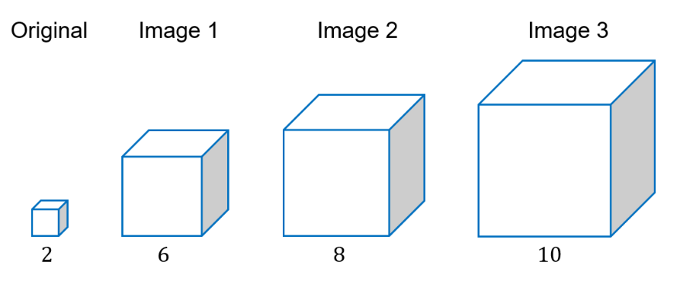
- Shown here is a cube of side length 2 and its images after enlargement. All units are in cm.

  - Complete this table, comparing each image to the original.
Cube | Original | Image 1 | Image 2 | Image 3
Length ratio | 1 | 1:3 | 1:4 | 1:5
Volume | 8 cm³ | 216 cm³ | 512 | 1000
Volume ratio | 1 | 1: ……  27 | 1:64 | 1:125
  - What would be the volume ratio if the length ratio is $1:n$?
$$1:n^{2}$$
  - What would be the volume ratio if the length ratio is:
    - 1:10? ………… ii 1:20? ………… iii 1:100? …………
1:1000 1:8000 1:1 000 000
  - What would be the volume ratio if the length ratio is $1:\frac{1}{2}$?
$$1:\frac{1}{8}$$
- Given that the following pairs of solids are similar, find the unknown volume using the information given. Round to 2 d.p. where appropriate.
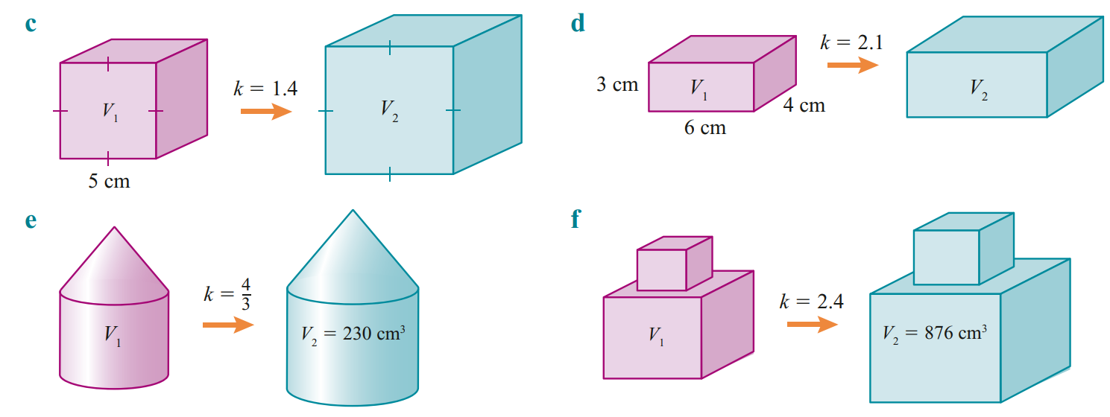  1. Length ratio:  2. Volumes in ratio:  3. Ratio table: | 666.79 cm³
  Original | $$:$$ | Image
  1 | $$:$$ | $${1.4}^{3}$$
  125 | $$:$$ | 343
97.01 cm³ | 63.37 cm³
- The matching lengths of two similar prisms are 2 cm and 5 cm.
  - Write the length ratio of the smaller to the larger prism.
$$2:5$$
  - Write the volume ratio of the smaller to the larger prism
$$8:125$$
  - If the volume of the smaller prism is 64 cm³, what is the volume of the larger prism?
$$\frac{x}{64}=\frac{125}{8}$$
$1000$ cm³

- The matching sides of two similar solids are in the ratio 3 : 4.
  - Write the volume ratio of the smaller to the larger prism.
$$27:64$$
  - If the volume of the larger solid is 384 cm³, what is the volume of the smaller solid?
$$\frac{x}{384}=\frac{27}{64}$$
$162$ cm³

- The surface area and volume of a solid are 350 cm² and 480 cm³ respectively.
The solid is enlarged using a scale factor $k=1.8$.
Calculate the surface area and volume of the larger solid.

$$360×{1.8}^{2}=1134 cm²$$
$380×{1.8}^{3}=2799.36 cm³$
- A box holds exactly 360 ball bearings.
If all the dimensions of the box are doubled, how many ball bearings would it hold?

New volume is 360 $×2^{3}=$ 2880 ball bearings

Development
- Complete the table.
$$Ratio of Lengths$$ | $$Ratio of Areas$$ | $$Ratio of Volumes$$
$$2:5$$ | $$4:25$$ | $$8:125$$
$$5:3$$ | 25:9 | 125:27
$$1:____$$  10 | 1:10 | $$____:1000$$
4:3 | $$16:____$$  9 | $$____:27$$  64
$$0.5:0.3$$ | 0.25 : 0.09 | 0.125 : 0.027
1:0.1 | $$1:0.01$$ | $$____:0.001$$
0.2 : 0.001 | 0.04 : 0.00001 | $$0.008:0.000001$$
$$a:____:____$$  $$a:b:c$$ | $$____:b^{2}:____$$  $$a^{2}:b^{2}:c^{2}$$ | $$____:____:c^{3}$$  $$a^{3}:b^{3}:c^{3}$$
$$2a:____:____$$  $$2a:3b:4c$$ | $$____:{9b}^{2}:____$$  $$4a^{2}:9b^{2}:16c^{2}$$ | $$____:____:{64c}^{3}$$  $$8a^{3}:27b^{3}:64c^{3}$$
$$a^{2}:b^{3}:c^{4}$$ | $$a^{4}:b^{6}:c^{8}$$ | $$a^{6}:b^{9}:c^{12}$$
$$\sqrt{a}:b:c^{\frac{3}{2}}$$ | $$a:b^{2}:c^{3}$$ | $$a^{\frac{3}{2}}:b^{3}:c^{\frac{9}{2}}$$

Mastery
- A model is made of a statue and the volumes of the statue and its model are in the ratio 27 : 1.
  - What is the ratio of the height of the statue to the height of the model?

$$3:1$$
  - What is the ratio of the surface areas?

$$9:1$$
- When it is hot, a dog cannot sweat to cool down but uses moisture evaporation from its tongue to regulate its body temperature. This is not effective for large animals.
Consider what would happen if a dog’s dimensions were increased by a factor of 10.
  - By what factor would its volume be increased?
1000
  - By what factor would the surface area of its tongue be increased?
100
  - What effect would this have on the animal?

The dog would produce far more heat but have relatively less surface area to dissipate it.
The doggy would overheat!

- The two jars are similar. What is the volume of the larger jar?
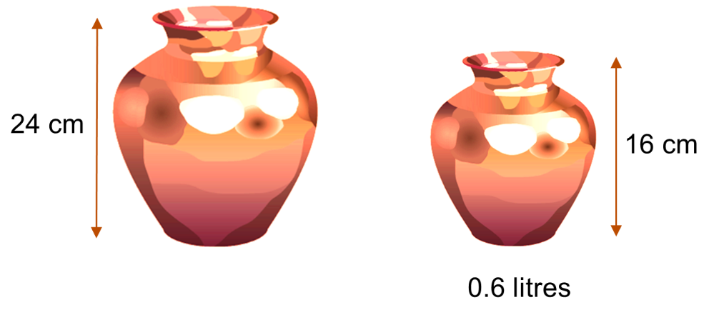

$$\frac{x}{0.6}={\left(\frac{24}{16}\right)}^{3}$$
$x=2.025$ L
- These cylinders are similar. What is the volume of the smaller cylinder? Answer in terms of $π$.
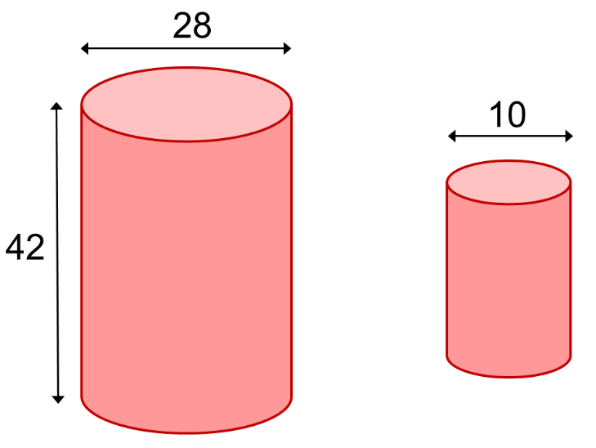

$$\frac{x}{π{\left(14\right)}^{2}\left(42\right)}={\left(\frac{10}{28}\right)}^{3}$$
$x=375π$ units³
- A solid metal ball is melted down and made into similar balls with $\frac{1}{5}$ the radius.
How many smaller solid balls can be made?

Each ball is ${\left(\frac{1}{5}\right)}^{3}=\frac{1}{125}$ the original volume
$∴$ 125
- These are two similar vases of difference sizes.
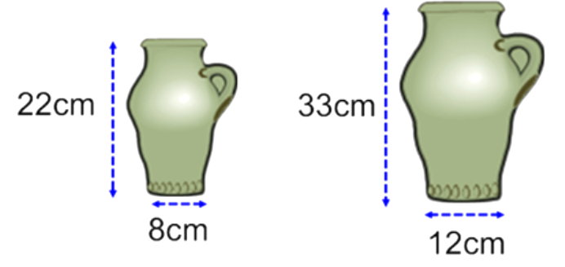
  - If the surface area of the smaller vase is 550 cm²,
Calculate the surface area of the larger vase.

$$\frac{x}{550}={\left(\frac{33}{22}\right)}^{2}$$
$x=1237.5$ cm²
  - If the volume of the larger vase is 3800 cm³,
Calculate the surface area of the smaller vase.

$$\frac{x}{3800}={\left(\frac{22}{33}\right)}^{2}$$
$$x=1688.\dot{8} cm^{2}$$

